|  |  |  |  |  |  |  |  |  |
| --- | --- | --- | --- | --- | --- | --- | --- | --- |
|  | CERTIFICATE Of ACHIEVEMENT | | | | | |  | |
|  | | | | | | | | |
|  | | THIS ACKNOWLEDGES THAT | | | |  | | |
|  | | | | | | | | |
|  | Raghav Bhardwaj | | | | | | |  |
|  | |  | |  |  |  | | |
|  | | HAS SUCCESSFULLY COMPLETED THE | | | |  | | |
|  | |  | | | |  | | |
|  | | **Smart Plant Feeder Challenge** | | | |  | | |
|  | |  | | | |  | | |
|  | April, 20, 2024 | |  | Ankush Sharma | | | |  |

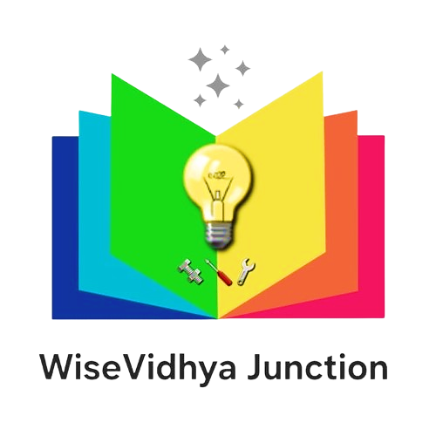Certificate of Achievement

This is to certify that [Raghav Bhardwaj]

Has demonstrated exceptional skills and innovation, earning the **1st Place** in the

**Smart Plant Feeder Challenge**

Presented with this certificate by WiseVidhya Junction in recognition of their outstanding performance and contribution to the field of technology.

Date: [20/04/2024]

Ankush Sharma

**WiseVidhya Junction**

